
Sardar Patel Institute of Technology
Bhavan’s Campus, Munshi Nagar, Andheri (W), Mumbai : 400058, India
(An Empowered Autonomous College Affiliated to University of Mumbai)
Department of Computer Engineering

EatFirm
Food Delivery Management System (FDMS)
A Modular Mobile Commerce, Order Fulfillment, and Real-Time Tracking Platform

Parameter | Project Metadata
Course | Software Engineering Lab (Semester 5, Academic Year 2026–2027)
Requirements Baseline | IEEE 830-1998 Approved Software Requirements Specification (SRS v1.0)
Application Type | Mobile Application (Flutter Cross-Platform compiled for Android APK)
Backend Architecture | Node.js (v22 LTS) + TypeScript 5.7 REST API ( /api/v1 )
Authoritative Store | PostgreSQL 15 Relational Database with Transactional Migrations
Deployment Target | Android Mobile Devices ( .apk ) via Local Wi-Fi Intranet ( http://192.168.x.x:5000/api/v1 )
Prepared By | - Piyush Orke (UID: 2024300151)  - Keertan Nayak (UID: 2024300148)
Demonstration Video | [Insert Video URL: e.g., YouTube / Google Drive Demo Link]
Source Repository | [Insert GitHub Repository Link]
Date of Submission | October 2026

Executive Summary & Contents

Contents

- ​Introduction & Project Scope
  - ​Problem Statement & Objectives
  - ​Scope & Operational Roles
- ​Software Requirements Baseline (SRS v1.0)
  - ​Functional Requirements Matrix
  - ​Non-Functional & Safety Requirements
  - ​Design Constraints & Open Decisions Register
- ​System Architecture & Design Models
  - ​Deployment Architecture & Context Model
  - Technology Decisions & ERD Domain Model
  - ​Core Algorithms & State Automata
- ​Implementation & Modular Roadmap
  - ​10-Module Execution Roadmap
  - ​Completed Modules & Codebase Directory Map
- ​User Interface & Screen Walkthrough
- Verification, Testing & Quality Gates
- ​Deployment & Operational Strategy
- ​Limitations & Future Scope
- ​Conclusion
- Appendix A. Demonstration Video Walkthrough Script
- Appendix B. Academic AI Assistance Log

Abstract
EatFirm is an enterprise-grade Food Delivery Management System (FDMS) engineered for the Semester 5 Software Engineering curriculum at SPIT, Mumbai, by Piyush Orke and Keertan Nayak. The system is built as a cross-platform Android mobile application (Flutter) backed by an asynchronous Node.js/TypeScript REST API and an authoritative PostgreSQL 15 relational database. Designed from an approved IEEE 830 SRS (v1.0), the platform replaces informal phone-based food ordering with an automated digital pipeline. The design enforces non-negotiable software engineering constraints: financial calculations are calculated exclusively server-side using fixed-point decimal arithmetic ( NUMERIC(12,2) ); customer orders adhere to an immutable single-restaurant cart boundary and an atomic finite state transition engine; and user data is protected via Role-Based Access Control (RBAC), bcrypt hashing, and automated log sanitization. Development spans a 10-module sequence where Modules 01 to 06 are 100% complete, verified, and passing all 44 automated tests, delivering foundational infrastructure, auth, restaurant onboarding, fuzzy discovery search, atomic checkout with idempotency, and Cash on Delivery (COD) invoicing.

Introduction & Project Scope

Problem Statement & Objectives
Traditional walk-in and phone-based restaurant ordering introduces severe frictions: communication errors during verbal dish customizations, lack of multi-restaurant comparison tools, kitchen peak-hour phone interruptions, and zero visibility into order preparation.
EatFirm automates this lifecycle with five core engineering objectives:

- Unified Mobile Pipeline: Enable customers to discover eateries, filter dishes, manage a single-restaurant cart, and place orders in under 5 minutes.
- Authoritative Financial Math: Eliminate floating-point roundoff errors by computing subtotal, 5% GST tax, delivery fees, and discounts strictly on the backend using fixed-point decimals ( SRS CO-7 ).
- Low-Overhead Operations: Give kitchen staff a 2-tap order acceptance interface ( SRS Section 5.4
Usability ) and instant menu availability toggling.
- Data Isolation & Security: Enforce Role-Based Access Control (RBAC) and protect against Insecure Direct Object References (IDOR).
- Deterministic Fulfillment: Enforce an immutable milestone lifecycle ( PLACED → ACCEPTED → PREPARING →
READY_FOR_PICKUP → OUT_FOR_DELIVERY → DELIVERED ).

Scope & Operational Roles
- In-Scope (v1.0): Customer self-service auth, restaurant onboarding with FSSAI verification, menu CRUD with veg/non-veg tags, full-text fuzzy search, single-restaurant cart boundary, scheduled orders, server bill math, idempotent order placement, COD payments, printable tax invoices, and real-time tracking presentation.
- Out-of-Scope (v1.0): Raw ingredient stock inventory, direct credit card vaulting/acquiring bank processing, table reservations, and train station delivery (deferred).

Operational Role | Target Device | Core System Capabilities | Usability & Performance Invariant
Customer | Android Phone | Browse eateries, search dishes, manage cart, place COD orders, track live status. | Intuitive Material 3 UI; search latency  ≤ 2.0s; clear veg indicators.
Restaurant Admin | Android Tablet/Phone | Onboard eatery, manage menu categories/items, toggle stock availability, accept orders. | High contrast; order acceptance in ≤ 2 taps; order alerts in ≤ 5.0s.

Operational Role | Target Device | Core System Capabilities | Usability & Performance Invariant
Delivery Partner | Android Phone | Inspect pickup/drop addresses, update delivery status, confirm delivery via customer OTP. | Zero typing while riding ( NFR-11 ); large button targets; fast OTP input.
System Admin | Web Browser / PC | Review and approve/reject restaurant onboarding applications, monitor audit logs. | High data density; complete audit logging for all privileged decisions ( NFR-27 ).

Software Requirements Baseline (SRS v1.0)

Functional Requirements Matrix
The functional baseline defines 73 functional requirements structured across 9 functional domains:

Functional Area | Requirements | What the System Delivers / Implemented Scope | Priority | Status
1. Accounts & Auth | REG-1..3 ,  LOGIN-1..3 | Registration with email/phone, uniqueness validation, OTP verification, bcrypt login, password reset, and role-based access control. | High | Implemented (Mod 02)
2. Restaurant & Menu | REST-1..6 | Restaurant profile submission with FSSAI license, admin approval workflow, dish CRUD, veg/non-veg tags, time-based hours, and specials. | High | Implemented (Mod 03)
3. Browse & Search | BROWSE-1..4 | Restaurant discovery within delivery radius, multi-attribute filtering (rating, price, distance), veg filters, and reordering from history. | High | Implemented (Mod 04)
4. Cart & Orders | CART-1..2 ,  ORDER-1..5 | Single-restaurant cart boundary, chef instructions, authoritative bill math (5% GST), scheduled orders, and idempotent order placement. | High | Implemented (Mod 05)
5. Payment & Invoicing | PAY-1..4 | Cash on Delivery (COD) tracking, collection recording by authorized riders, payment audit timeline, and immutable digital tax invoices. | High | Implemented (Mod 06)
6. Real-Time Tracking | TRACK-1..4 | Order fulfillment milestone progression ( Placed to Delivered ), status alerts, live delivery partner telemetry, and handover OTP. | High | UI Implemented (Mod 07)
7. Partner Assignment | DEL-1..4 | Automated nearest-neighbor delivery partner assignment, pickup/drop navigation coordinates, and partner reassignment timer. | High | Planned (Mod 08)
8. Customer Support | SUP-1..4 | In-app support ticketing, refund claims on damaged/delayed orders, independent restaurant and driver ratings, and reward vouchers. | Med / Low | Planned (Mod 09)
9. Train Delivery | TRAIN-1..3 | In-train seat delivery configured via passenger PNR number, platform tracking, and station arrival synchronization. | Low | Deferred (Post-v1.0)

Non-Functional & Safety Requirements
Requirement ID | Engineering Specification | How the Architecture Enforces It
NFR-1 (Peak Concurrency) | Support ≥ 200 concurrent users without slowdown. | Non-blocking Node.js event loop, PostgreSQL connection pool, indexed lookups.
NFR-2 & 4 (UI  Latency) | Menus load in ≤ 3.0s; search suggestions in ≤ 2.0s. | Trigram GIN indexes ( pg_trgm ) on names/cuisines; debounced client queries.
NFR-5 (Kitchen Alert) | New orders appear on kitchen screen in ≤ 5.0s. | Indexed polling / event-driven notification channels scoped to restaurant ID.
NFR-6 (Tracking Refresh) | Rider GPS coordinates refresh ≥ once every 15s. | Client polling cadence with prepared WebSocket telemetry schema for Module 07.
NFR-8 (Database Scale) | ≥ 50,000 orders with queries executing in ≤ 3.0s. | B-tree index idx_orders_customer (customer_id, created_at DESC) with pagination.
NFR-9 (Maps Caching) | Distance and travel estimates cached for 15 minutes. | Server in-memory cache keyed by origin/destination coordinates ( CO-8 ).
NFR-10 (Atomicity) | Orders, payments, and balances never save partially. | Enclosed in PostgreSQL transactions; any step failure executes ROLLBACK .
NFR-11 (Rider Safety) | Partner mobile app requires zero typing while riding. | Big touch targets; delivery confirmed strictly using customer 4-digit OTP.
NFR-12 (Dietary Safety) | Clear veg/non-veg tags on every menu item and cart. | Database boolean is_veg rendered as standardized green/red visual indicators.
NFR-13 (Price Accuracy) | Bill presented before payment; no unexpected changes. | Authoritative server bill calculation returned to client; client never submits total.
NFR-14 (Destructive Action) | Modal confirmation required before irreversible steps. | Two-step confirmation dialogs for order cancellation and menu item deletion.
NFR-16 (Dispute Audit) | Cancelled orders permanently retained; never deleted. | Soft status update ( fulfillment_status = 'CANCELLED' ); hard DELETE prohibited.
NFR-17 (Password Security) | Passwords hashed securely; plaintext never logged. | Bcrypt hashing (10 salt rounds); JSON logger redacts  password , token , otp .
NFR-18 (PCI-DSS  Boundary) | Server never stores raw card numbers or CVVs. | Scope exclusion: only COD and third-party gateway intents handled on server.
NFR-20 & 22 (RBAC  / IDOR) | Role boundaries enforced; users access only owned data. | JWT claims verified in middleware; queries scoped by  customer_id returning 404/403.
NFR-24 (Server Validation) | All input validated on server side. | Strict runtime Zod schema parsing on all incoming POST, PUT, and PATCH bodies.
NFR-28 (Customer Privacy) | Customer phone number masked after delivery. | Phone numbers stripped from delivery partner views once order enters DELIVERED .

Design Constraints & Open Decisions Register

- Constraints ( CO-1 to CO-10 ): Relational PostgreSQL 15 database; standard REST JSON envelopes; mandatory HTTPS/TLS 1.2+; exact decimal monetary math ( NUMERIC(12,2) ) prohibiting floating-point variables; UTC timestamps converted to IST ( DD-MM-YYYY ); INR formatting ( ₹1,25,000.00 ); mandatory FSSAI food license numbers for restaurants.
- Open Architectural Decisions (SRS Appendix C):
  - TBD-1 (Payment Gateway): Abstracted behind PaymentGateway interface; Module 06 implements Cash on Delivery (COD) as the primary authoritative payment channel.
  - TBD-2 (Maps & Location): Haversine distance calculation and coordinate caching implemented in Module 04.
  - TBD-3 (SMS & OTP Gateway): Abstracted behind NotificationService ; OTPs are deterministically logged in development.
  - TBD-4 (Partner Assignment): Algorithm specified for Module 08: nearest available rider within 3 km with lowest batch load.

System Architecture & Design Models

Deployment Architecture & Context Model
EatFirm is structured as a decoupled multi-tier mobile application communicating over local Wi-Fi with an asynchronous REST server and PostgreSQL database:
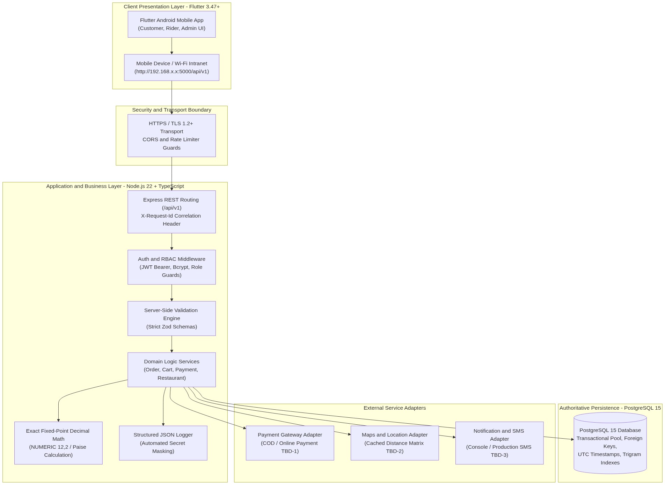
Figure 1. Multi-tier deployment architecture showing Flutter Android mobile client, Node.js REST API layer, and authoritative PostgreSQL 15 database store.
In strict accordance with Figure 2 of the approved SRS, the system context model defines the boundaries with external actors and third-party services:
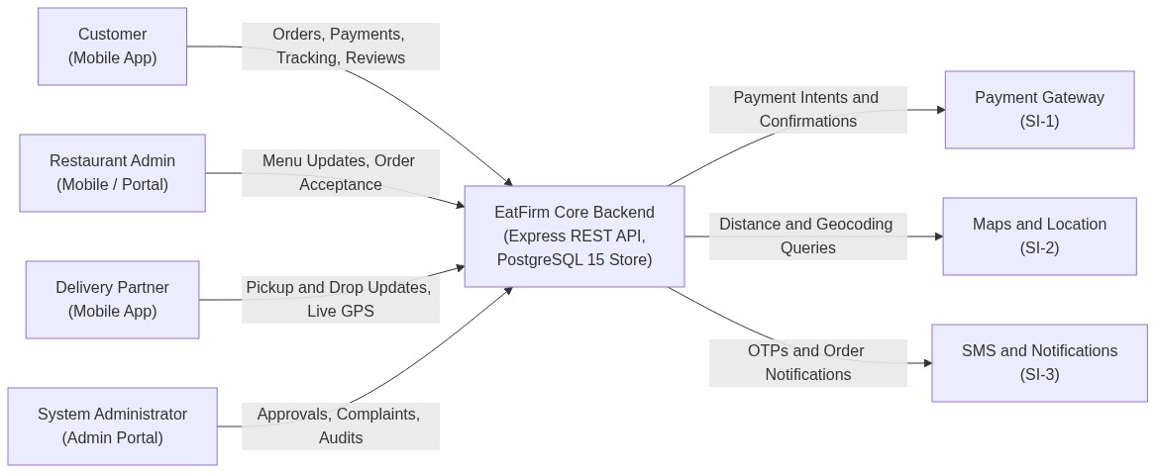
Figure 2. System context model defining actor interactions and external software interfaces (SI-1, SI-2, SI-3).

Technology Decisions & ERD Domain Model

Architecture Layer | Chosen Technology | Engineering Justification & Constraint Adherence
Mobile Presentation | Flutter 3.47+ / Dart 3.13+ | Compiles to native Android APK; Material 3 tokens, declarative GoRouter, fluid animations.
Backend REST API | Node.js v22 (LTS) + Express | High throughput non-blocking event loop; efficient JSON parsing and lightweight routing.
Language & Typing | TypeScript 5.7 (Strict Mode) | Complete static type safety preventing runtime crashes across models and services.
Schema Validation | Zod | Runtime schema validation sanitizing all inbound payloads before domain logic ( NFR-24 ).
Authoritative Store | PostgreSQL 15+ | Full ACID compliance, foreign keys, trigram text search, and exact  NUMERIC(12,2) support.
Authentication | JWT + bcrypt | Stateless HMAC-SHA256 JWT tokens with role claims; 10-round salted bcrypt hashing ( NFR-17 ).
Observability | Structured JSON Logging | Correlation IDs ( X-Request-Id ) and automated sanitization of sensitive keywords ( password , otp ).
The normalized relational schema implemented across PostgreSQL migrations 001 through 006 captures all primary domain entities:
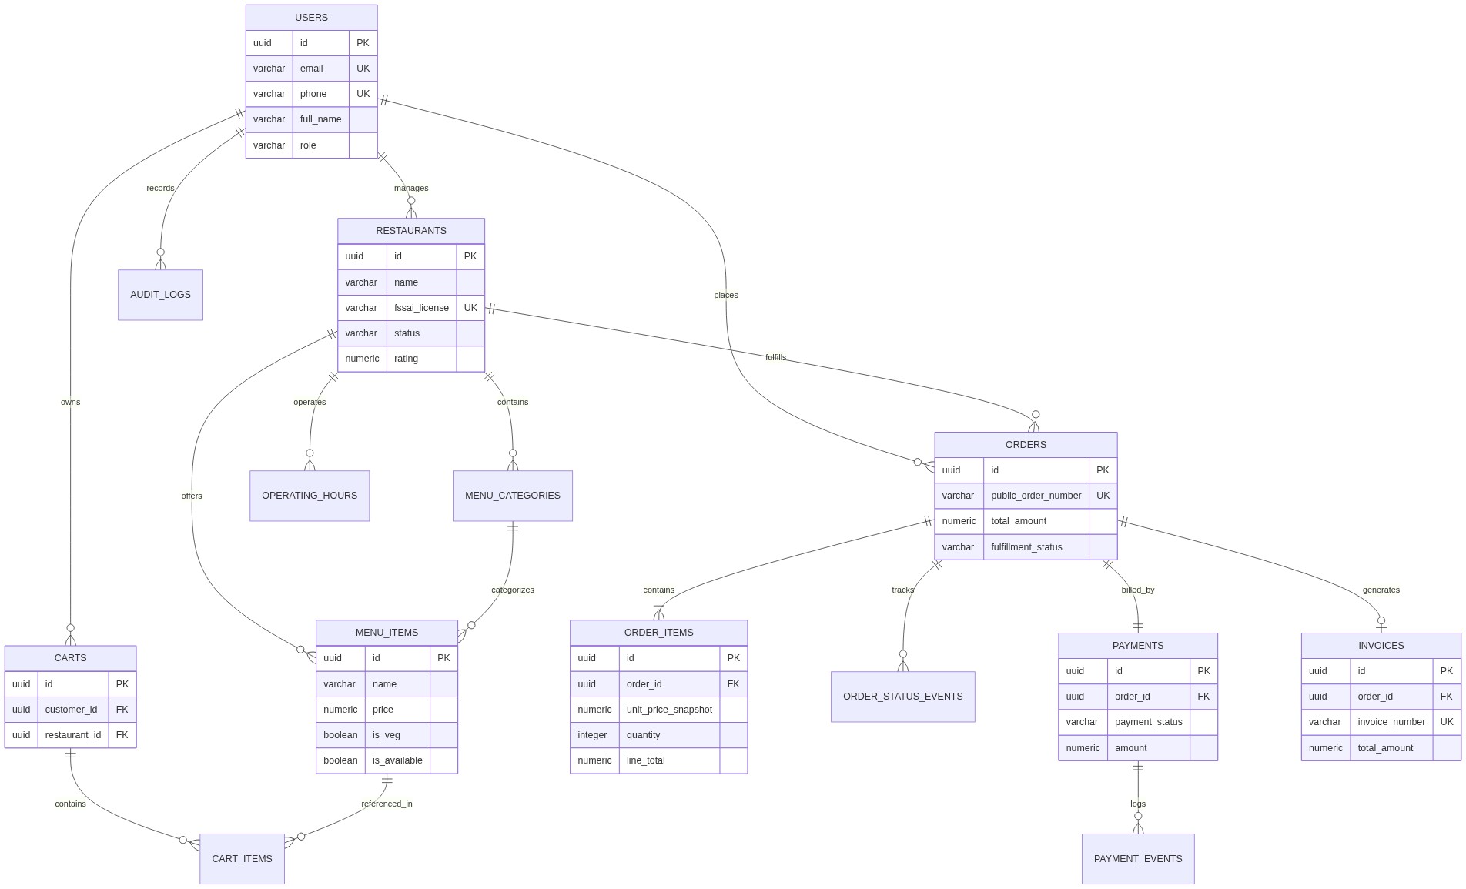
Figure 3. Entity-Relationship Diagram representing core relational entities, foreign key constraints, and 1:N cardinality mappings.

Core Algorithms & State Automata
    - Order Fulfillment Finite State Machine (SRS Figure 4)

In strict compliance with Figure 4 of the approved SRS, every order moves through an explicit, forward-only finite state machine:
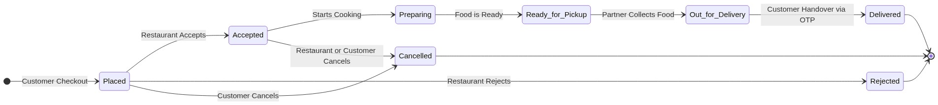
Figure 4. Deterministic order fulfillment state machine showing operational transitions from checkout to doorstep delivery.

Transition Rules:

      - Once an order enters PREPARING or beyond, customer self-cancellation is strictly forbidden to protect restaurant food preparation costs ( SRS NFR-14 , NFR-16 ).
      - Every transition records an immutable audit record in order_status_events capturing from_status ,
to_status , actor_user_id , actor_role , and UTC timestamp.
      - Orders can never be deleted from the database. A cancelled order is permanently retained with status CANCELLED
( SRS Section 6 ).
    - Exact Fixed-Point Decimal Monetary Engine

To comply with SRS CO-7 and eliminate IEEE 754 floating-point inaccuracies, monetary amounts are calculated strictly on the server:

- All values stored in PostgreSQL as NUMERIC(12,2) .
- Financial equations enforced in domain logic:
$Line Total=Unit Price Snapshot×Quantity$
$Subtotal=\sum{}Line Totals$
$Tax Amount={Round}_{2}\left(Subtotal×0.05\right) \left(5\% GST\right)$
$Total Amount=Subtotal+Delivery Fee+Tax Amount-Discount Amount$
- The client application never computes or submits the payable total; the frontend displays what the server authoritatively returns ( NFR-13 ).
    - Single-Restaurant Cart Boundary & Idempotency

      - Single-Restaurant Cart Enforcement: A customer's active cart can only contain dishes from a single restaurant at any time. Adding an item from a second eatery triggers an explicit confirmation dialog asking the customer to either clear the existing cart or retain it.
      - Idempotent Order Creation ( ORDER-4 ): To prevent duplicate orders on double-taps or network retries, checkouts include a UUID v4 idempotencyKey backed by a unique database constraint ( idx_orders_idempotency ). Duplicate requests safely return the existing order.
      - Role-Based Guards & IDOR Defense: JWT claims are checked via authGuard.ts . Queries append WHERE customer_id = :userId to prevent IDOR access ( NFR-22 ).

Implementation & Modular Roadmap

10-Module Execution Roadmap
EatFirm is engineered following an incremental 10-module roadmap:
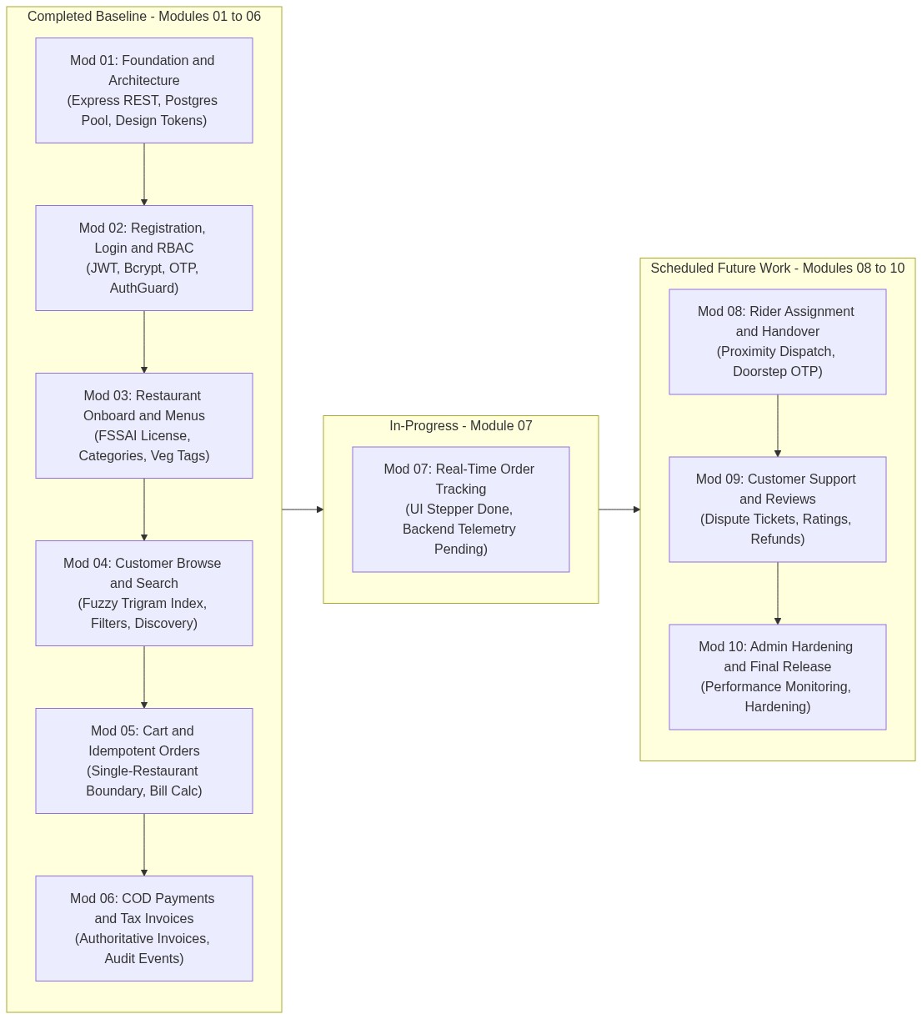
Figure 5. Modular implementation progress showing Modules 01 to 06 completed, Module 07 in-progress, and Modules 08 to 10 planned.

Completed Modules & Codebase Directory Map

- Module 01 (Foundation & Architecture): Express app bootstrap, structured JSON logging with secret masking, request correlation tracking ( X-Request-Id ), rate limiting, global error envelope middleware, exact decimal money math, and PostgreSQL connection pool ( 001_foundation.sql ).
- Module 02 (Auth, Sessions & RBAC): Migration 002_auth.sql , bcrypt password hashing, JWT token issuance, OTP generation for registration and password reset, and role verification guards. Flutter screens: Login, Register, OTP, Password Reset, Profile.
- Module 03 (Restaurant Onboarding & Menus): Migration 003_restaurant.sql , restaurant registration with FSSAI license, admin approval workflow, dish CRUD, veg/non-veg flags, availability toggles, and operating hours. Flutter screens: Onboarding, Dashboard, Menu Editor, Hours, Approvals.
- Module 04 (Customer Browse & Search): Migration 004_browse.sql with GIN trigram indexes ( pg_trgm ), distance calculation, price/rating filters, pure-veg filter toggle, and restaurant comparison. Flutter screens: Discovery, Search, Restaurant Menu.
- Module 05 (Cart, Checkout & Orders): Migration 005_cart_order.sql , single-restaurant cart boundary, chef cooking notes, scheduled delivery, server bill calculation, UUID idempotency keys, order cancellation guards, and history pagination. Flutter screens: Cart, Checkout, Confirmation, Order History, Detail.
- Module 06 (COD Payments & Tax Invoices): Migration 006_cod_payment_invoice.sql , Cash on Delivery payment tracking, collection recording by authorized riders, payment audit timeline, and immutable digital tax invoices in JSON and printable HTML. Flutter screen: Invoice Detail.
- Module 07 to 10 Status: Module 07 tracking UI screen completed; backend telemetry schema, partner dispatch (Module 08), customer dispute ticketing (Module 09), and administrative hardening (Module 10) are scheduled.

EatFirm/
├── backend/
│ ├── src/
│ │ ├── config/ # Zod schema validation & environment configuration
│ │ ├── database/ # Connection pooling & migration scripts (001 to 006)
│ │ ├── logger/ # Structured JSON logging with automated redaction
│ │ ├── middleware/ # AuthGuard, RequestId, RateLimiter, ErrorHandler
│ │ ├── models/ # TypeScript domain interfaces & data transfer types

│ | │ | ├── | routes/ |  | # | auth, cart, health, order, payment, restaurant
│ | │ | ├── | services/ |  | # | Business logic: auth, cart, order, payment, restaurant
│ | │ | ├── | utils/ |  | # | Exact money math, response envelopes, pagination
│ | │ | ├── | app.ts |  | # | Express application configuration
│ | │ | └── | server.ts |  | # | Bootstrap, graceful shutdown & signal handlers
│ | ├── tests/ # 11 test suites covering API, auth, browse, cart, money
│ | └── package.json
│
├── | frontend/
│ | ├── lib/
│ | │ ├── core/
│ | │ │ ├── constants/ # App dimensions, network timeouts, endpoints
│ | │ │ ├── localization/# AppStrings dictionary (SRS Section 6 compliance)
│ | │ │ ├── network/ # ApiClient, ApiExceptions, Envelope unwrapping
│ | │ │ ├── routing/ # GoRouter declarative routes & auth guards
│ | │ │ ├── theme/ # Material 3 tokens, Typography, Colors, Responsive
│ | │ │ └── utils/ # IST date formatter (DD-MM-YYYY) & INR currency
│ | │ ├── features/
│ | │ │ ├── auth/ # Login, Register, OTP, Password Reset, Profile
│ | │ │ ├── browse/ # Customer Discovery, Search, Menu, Filters
│ | │ │ ├── cart_order/ # Cart, Checkout, Confirmation, History, Detail
│ | │ │ ├── foundation/ # Bootstrap, NavigationShell, Showcase
│ | │ │ ├── payment_invoice/ # Tax Invoice Viewer, Payment Tracking
│ | │ | │ | ├── | restaurant/ | # | Dashboard, Menu CRUD, Operating Hours, Approvals
│ | │ | │ | └── | tracking/ | # | Live Order Timeline & Telemetry Scree | n
│ | │ | ├── | shared/
│ | │ | │ | └── widgets/ |  | # | Reusable UI buttons, cards, text fields, dialogs
│ | │ | └── | main.dart |  | # | Flutter application entry point
│ ├── test/ # Unit, widget, and feature test suites
│ └── pubspec.yaml
│
├── README.md # Project documentation & architectural summary
└── SRS_FDMS.docx.pdf # Authoritative Software Requirements Specification

User Interface & Screen Walkthrough

The EatFirm Android mobile application provides distinct, role-tailored user interfaces. The visual walkthrough pairs each screen with its operational role:

Authentication & Verification Screens (Figures 6 & 7)

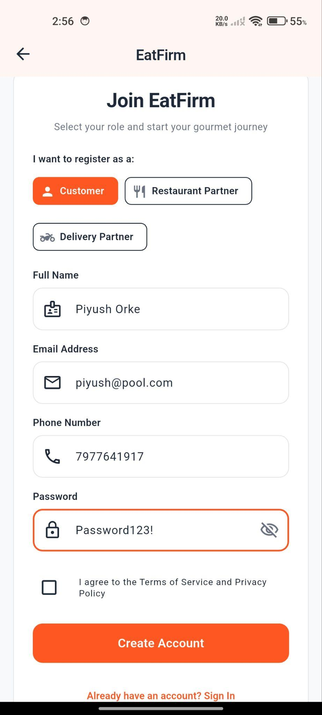
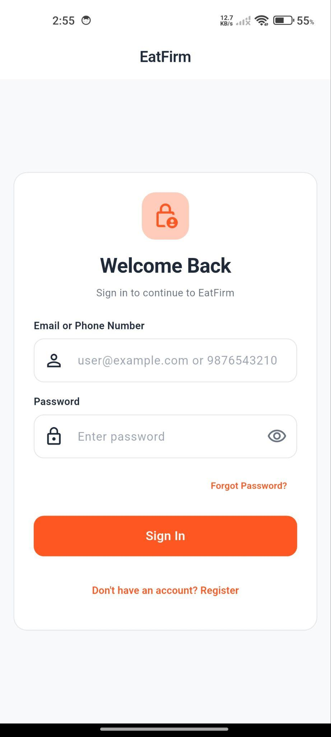
Figure 6. Mobile authentication screens showing phone/email login, role selection toggle, and input validation.

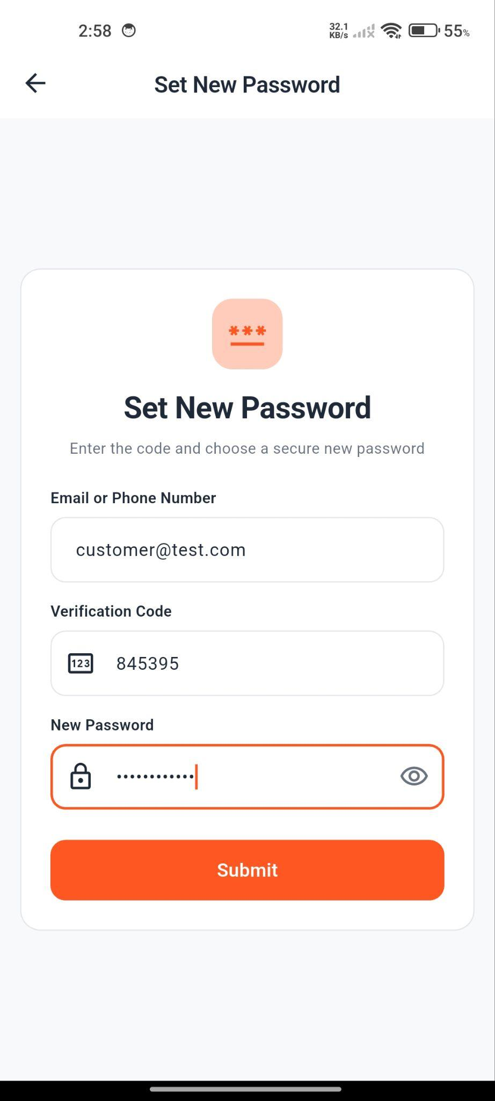
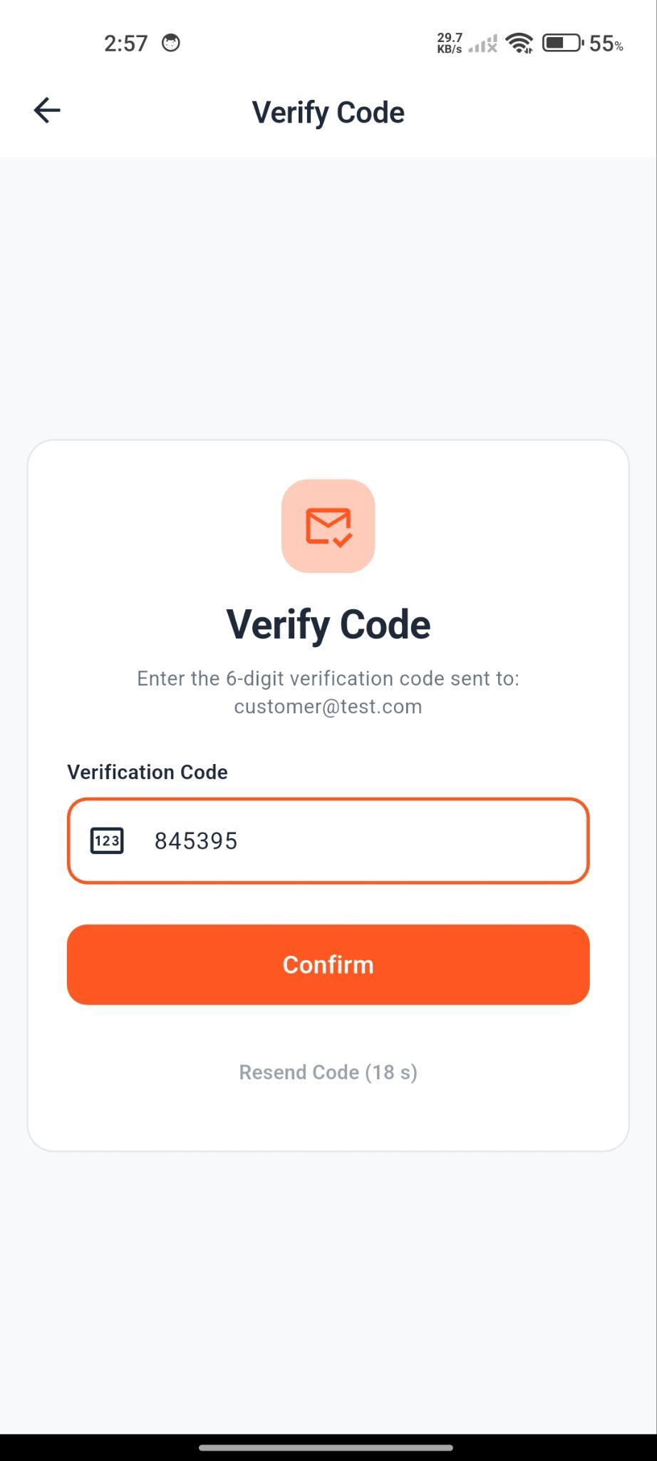
Figure 7. Six-digit pin verification interface with resend countdown timer and secure password reset.

The sign-in interface handles customer and restaurant logins with real-time field validation. Registration captures phone, email, password, and mandatory terms acceptance ( SRS Section 6 ). Identity verification uses an auto-focusing 6-digit OTP screen with a 60-second resend countdown.

Customer Discovery & Filtering Screens (Figures 8 & 9)

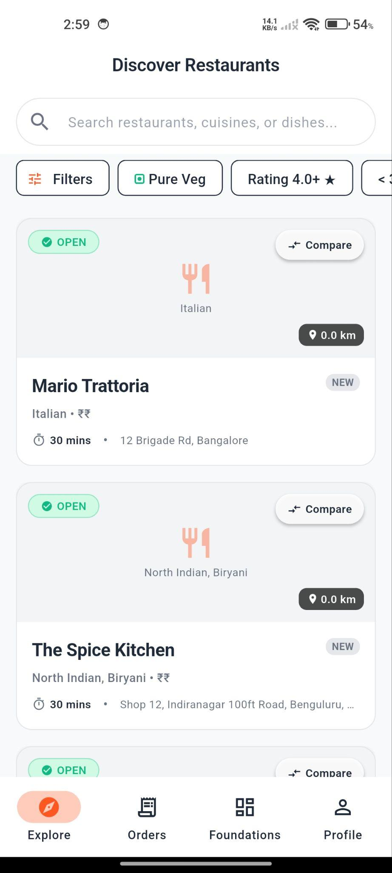
Figure 8. Discovery feed with debounced search query, rating badges, delivery duration chips, and Pure Veg filter.

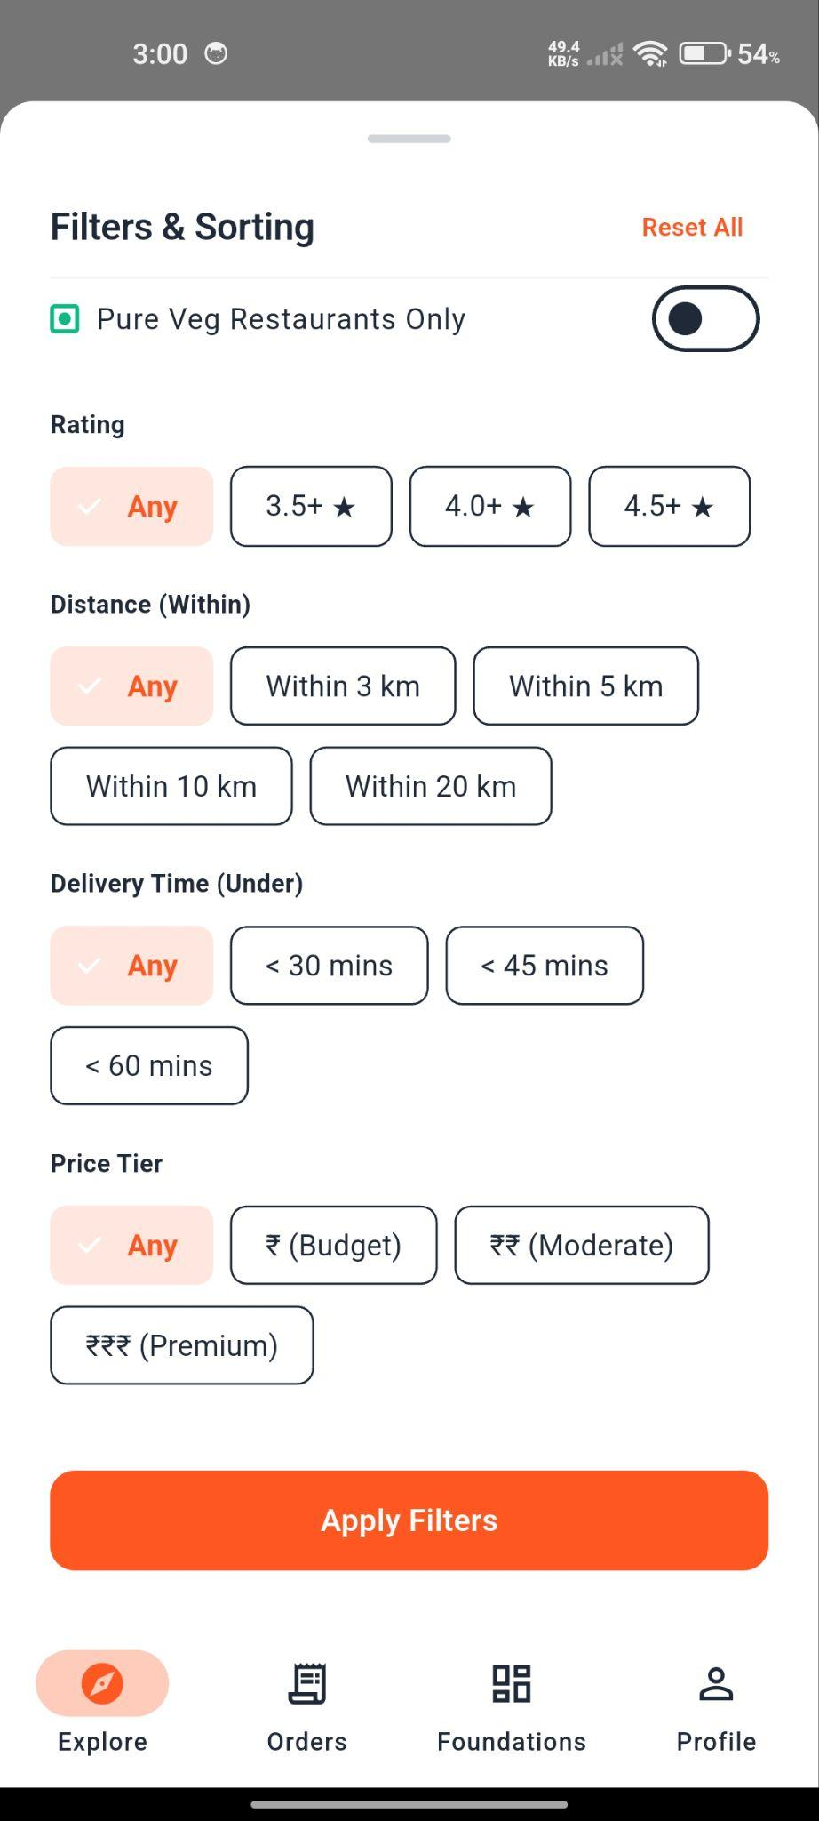
Figure 9. Multi-attribute filter drawer (rating, distance, price band) and side-by-side restaurant comparison modal.

The discovery feed (CustomerDiscoveryScreen) provides real-time debounced search matching restaurant names and cuisines ( NFR-4 ), a Pure Veg toggle, rating chips, and a comparison drawer displaying delivery fees and ratings side by side.

Restaurant Menu & Cart Customization (Figures 10 & 11)

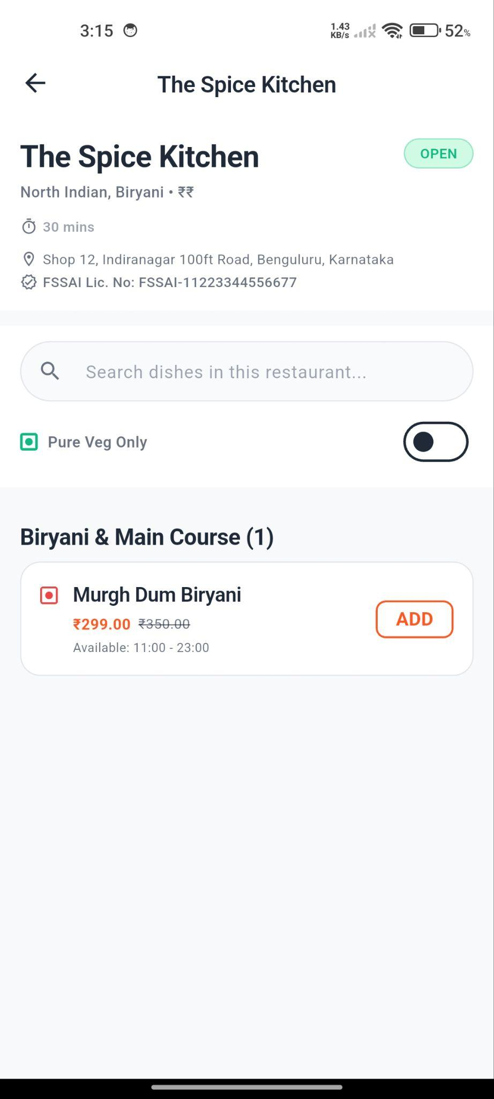
Figure 10. Restaurant menu interface displaying FSSAI license, categories, and veg/non-veg indicators.

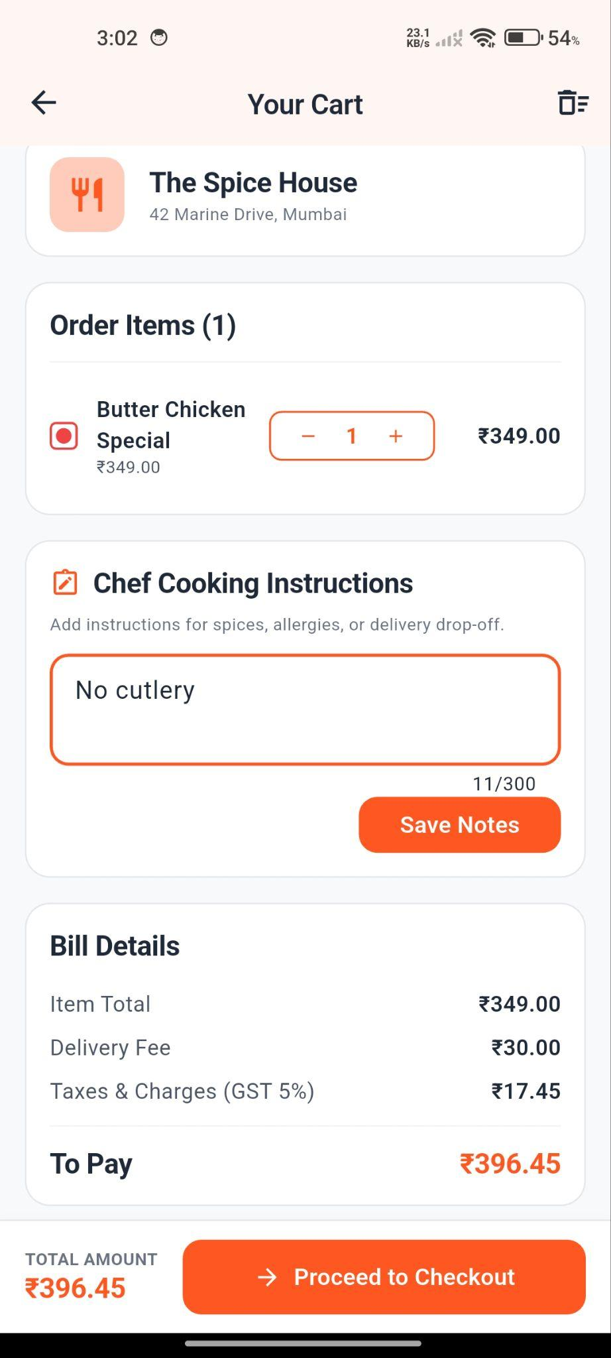
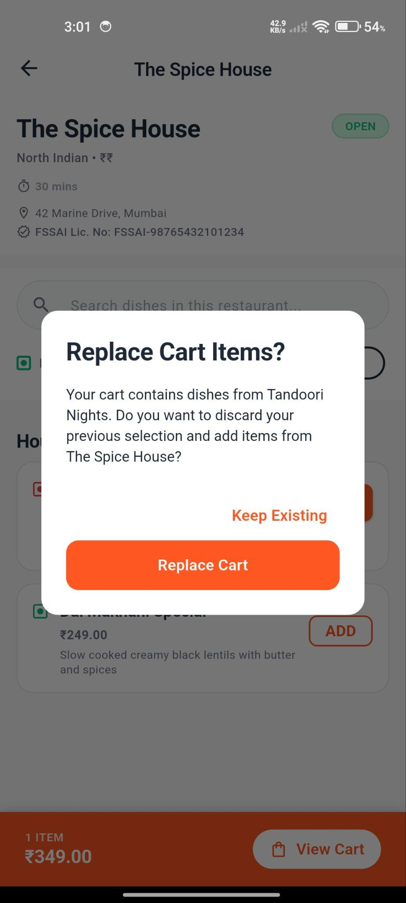
Figure 11. Shopping cart interface showing item customizations, chef instructions, and single-restaurant boundary alert.

The restaurant menu displays the eatery's operating hours, category tabs, and mandatory FSSAI food license number ( SRS Section 6 ). Each dish prominently renders a standardized veg (green dot) or non-veg (red dot) indicator ( NFR-12 ). The cart interface supports item notes, chef instructions, and enforces the single-restaurant boundary alert modal ( CART-1 , CART-2 ).

Checkout & Order History Timeline (Figures 12 & 13)

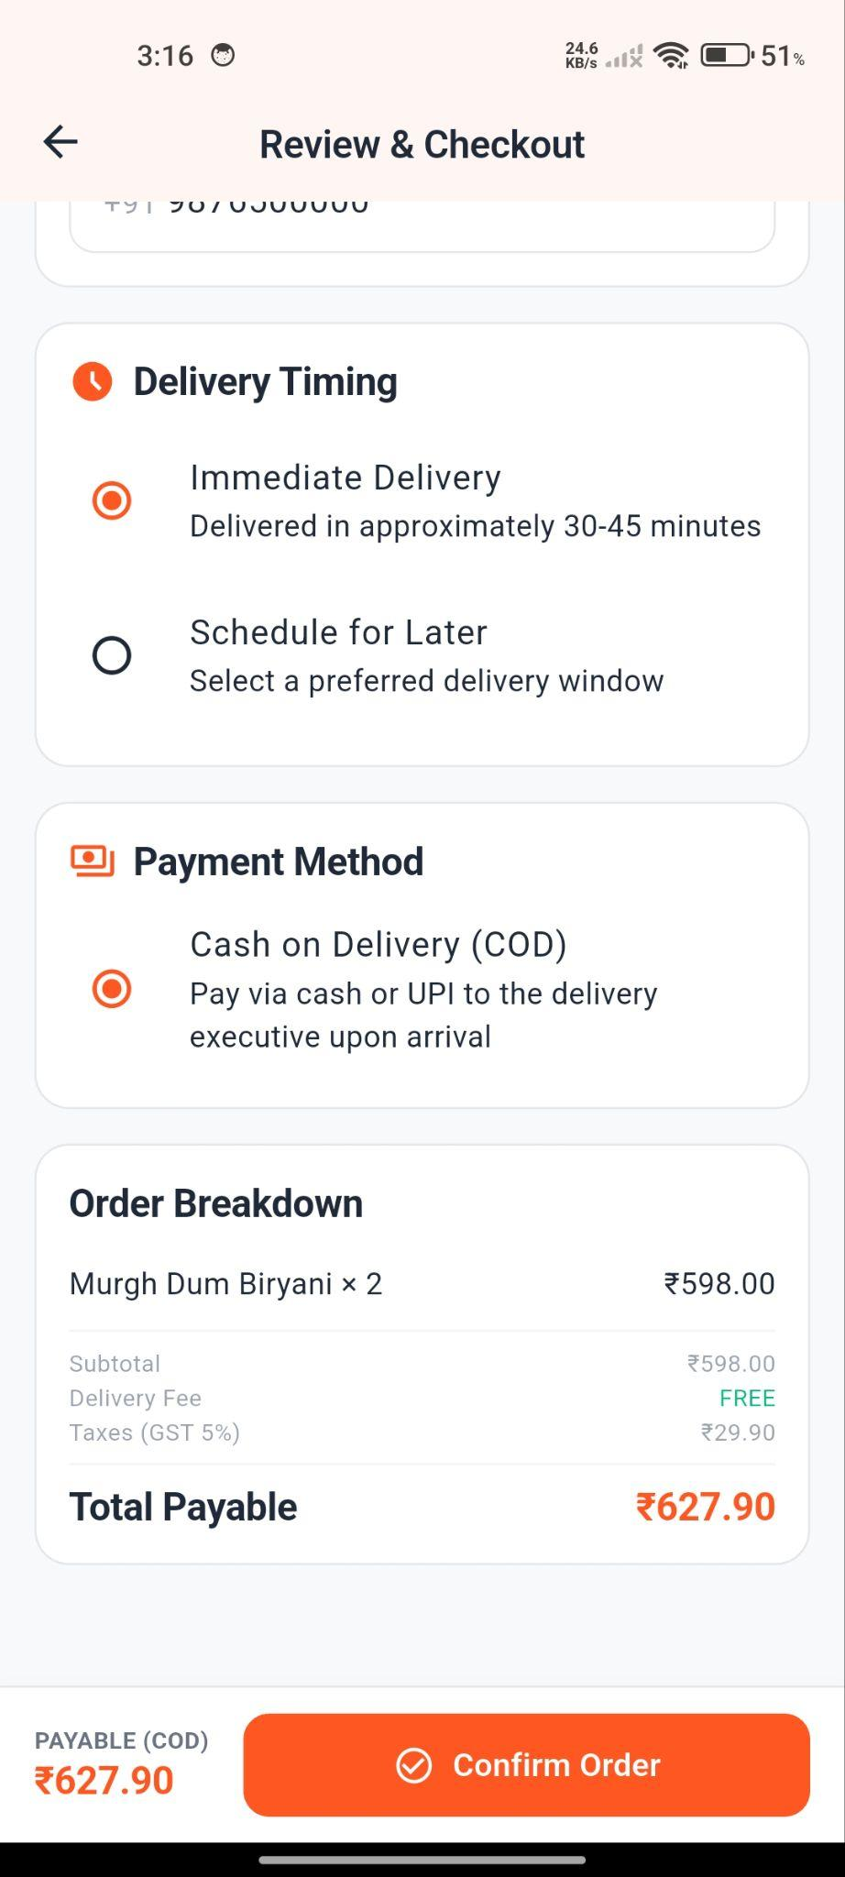
Figure 12. Checkout interface displaying authoritative bill calculation (subtotal, delivery fee, 5% GST, and total payable).

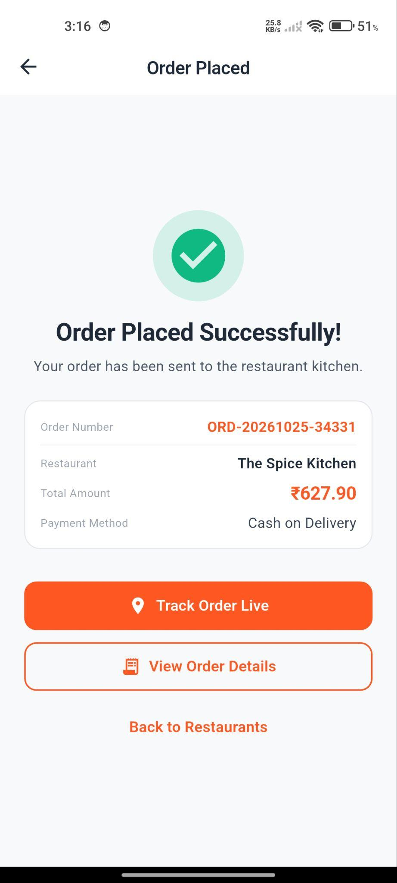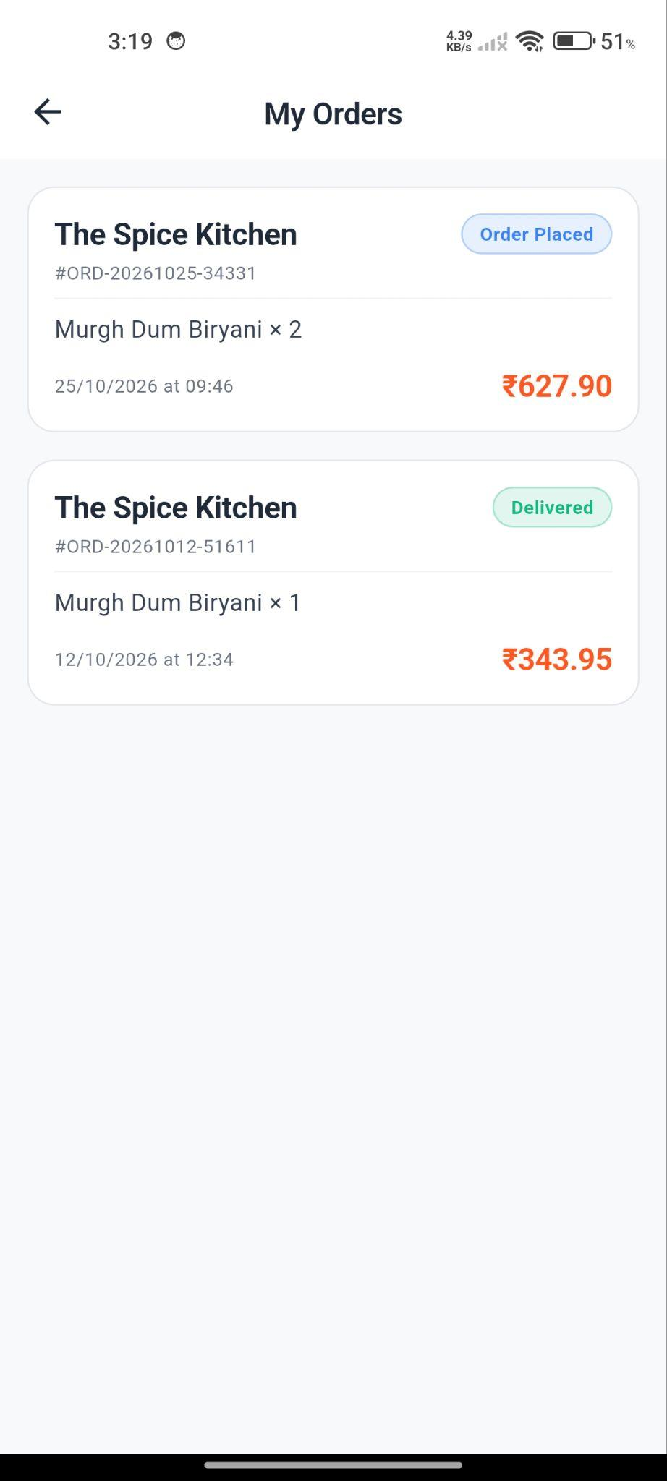
Figure 13. Order confirmation screen displaying unique order number and historical order timeline.

The checkout screen captures delivery address and phone number, presents payment options (COD / Online), and displays the authoritative bill breakdown ( ORDER-1 , NFR-13 ). Upon placement, the confirmation screen displays the unique public order number ( ORD-YYYYMMDD-XXXX ) and links to the order timeline.

Tax Invoice & Real-Time Tracking Screens (Figures 14 & 15)

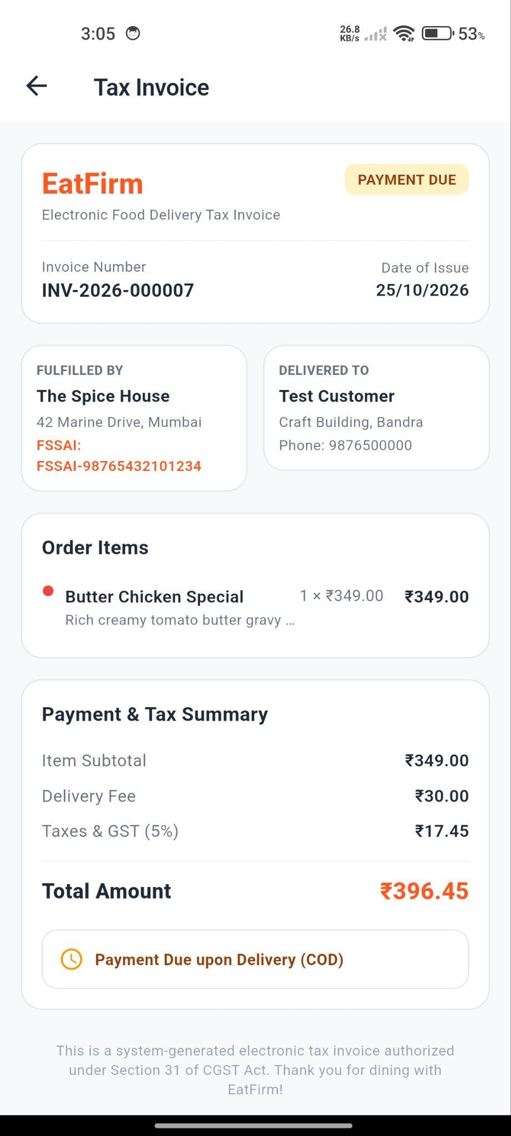
Figure 14. Official digital tax invoice matching order snapshot data with printable preview.

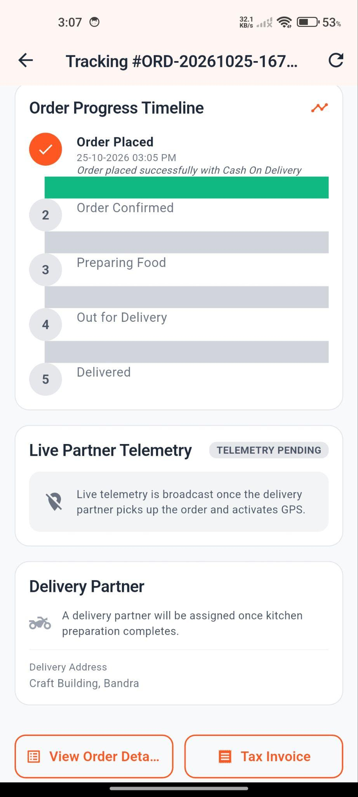
Figure 15. Real-time fulfillment tracking screen showing progress milestones, delivery partner card, and delivery OTP.

In compliance with PAY-3 , confirmed orders generate an immutable digital tax invoice containing order snapshots, FSSAI numbers, and GST breakdown. The tracking interface (OrderTrackingScreen) renders the fulfillment milestone stepper, assigned rider details, and the 4-digit customer handover OTP.

Restaurant Dashboard (Figures 16)

Figure 16. Restaurant operations dashboard with incoming order queue and menu editing dialog.

Kitchen staff utilize the restaurant dashboard to view incoming orders and accept or advance them in two taps ( SRS Usability ). The menu editor enables instant stock toggles ( REST-4 ).

Verification, Testing & Quality Gates

Testing Strategy & Execution Results (44 Tests Passing)
EatFirm enforces a strict multi-tier quality gate spanning unit math tests, database integration suites, mobile widget tests, and static type audits:

======================================================================
EatFirm Quality Gate Summary
======================================================================
Backend Node.js Integration Suite : 19 Tests Passing (100%) Frontend Flutter Widget Suite : 25 Tests Passing (100%) Total Automated Quality Gates : 44 Passing / 0 Failures
======================================================================

Subsystem | Test Suite File | Covered Assertions | Test Count | Result
Backend | money.test.ts | Exact decimal multiplication, line totals, 5% GST calculation, formatting. | 4 | PASS
Backend | migrator.test. ts | Schema migration execution, rollback capability, audit logging. | 2 | PASS
Backend | api.test.ts | Response envelopes, correlation ID headers, 404 handler, rate limiter. | 4 | PASS
Backend | auth.test.ts | User signup, bcrypt hash verification, JWT issuance, RBAC route protection. | 3 | PASS
Backend | restaurant.tes t.ts | Restaurant registration, admin approval, menu item CRUD, availability toggling. | 2 | PASS
Backend | cart_order.tes t.ts | Single-restaurant cart constraint, order idempotency, status transitions. | 2 | PASS
Backend | payment_invoic e.test.ts | COD collection recording, payment events, immutable tax invoice generation. | 2 | PASS
Frontend | theme_test.dar t | Material 3 color tokens, typography scales, spacing tokens. | 5 | PASS
Frontend | responsive_tes t.dart | Breakpoint adaptation ( < 600px mobile bottom nav vs  &ge; 600px rail navigation). | 4 | PASS
Frontend | api_client_tes t.dart | Request correlation injection, token header attachment, 401 unauthenticated redirect, error parsing. | 6 | PASS
Frontend | auth_test.dart | Email and phone regex validation, password length checks, button loading state toggles. | 5 | PASS
Frontend | widgets_test.d art | Empty states, error dialogs, veg indicator rendering, badge variants. | 5 | PASS
Total | All 11 Suites | Comprehensive end-to-end verification across Modules 01 to 06 | 44 | 100% PASS

Requirements Traceability Matrix (RTM)
SRS Requirement | Implementing Architecture Component | Verification Suite | Status
REG-1..3 , LOGIN-1..3 | authService.ts , auth.ts ,  auth/screens/ | auth.test.ts ,  auth_test.dart | Verified
REST-1..6 | restaurantService.ts ,  restaurant/screens/ | restaurant.test.ts | Verified
BROWSE-1..3 | restaurant.ts , browse/screens/ | browse.test.ts | Verified
CART-1..2 ,  ORDER-1..4 | cartService.ts ,  orderService.ts , cart_order/ | cart_order.test.ts | Verified
PAY-1 , PAY-3 | paymentService.ts ,  payment_invoice/ | payment_invoice.test  .ts | Verified
TRACK-1..3 | tracking/screens/order_tracking  _screen.dart | tracking_test.dart | Verified (UI)
CO-7 , NFR-10 | utils/money.ts , database/db.ts | money.test.ts | Verified
NFR-17..24 | authGuard.ts , logger.ts ,  routes/ | api.test.ts | Verified

Verification Gaps & Unexecuted Release Gates
- High Concurrency Load Testing ( NFR-1 ): Synthetic 200-concurrent-user performance load testing remains to be executed against the backend server.
- Physical Cellular SMS Dispatch ( SI-3 ): OTP generation has been tested via console logging; physical cellular delivery via an Indian DLT-registered SMS gateway is pending contract finalization.
- Live Payment Gateway Callback ( SI-1 ): Cash on Delivery payment flows are fully validated; production payment gateway webhooks (Razorpay/Stripe) await production merchant credentials.

Deployment & Operational Strategy

Android APK Compilation & Local Wi-Fi Intranet Networking
EatFirm is packaged as an Android application package ( .apk ) using the Flutter toolchain:

flutter build apk --release

The compiled binary ( app-release.apk ) is installed onto physical Android testing smartphones via USB or local network transfer. During testing and evaluation, the mobile app communicates with the host development workstation running the Node.js backend over the local Wi-Fi router:

flutter run --dart-define=API_URL=http://192.168.1.36:5000/api/v1

Server Environment Setup & Database Migrations
The Node.js server is configured via backend/.env with runtime validation enforced through Zod schemas (config/env.ts):
PORT=5000 HOST=0.0.0.0
NODE_ENV=development DB_HOST=127.0.0.1 DB_PORT=5432
DB_NAME=eatfirm_dev DB_USER=postgres
DB_PASSWORD=[SECURED_DATABASE_PASSWORD] JWT_SECRET=[CRYPTOGRAPHIC_32_CHAR_SECRET_KEY] JWT_EXPIRY=24h
LOG_LEVEL=info

Database schema migrations are executed using the custom transactional migration runner

npm run migrate # Execute forward schema migrations npm run migrate:down # Roll back the latest migration

Automated daily database dumps ( NFR-15 ) are scheduled with a 30-day retention policy:
pg_dump -U postgres -d eatfirm_dev -F c -b -v -f "/backups/eatfirm_$(date +%Y%m%d).

Limitations & Future Scope

While EatFirm delivers a robust ordering and fulfillment baseline across Modules 01 to 06, several functional extensions are planned for subsequent iterations:
- Backend Telemetry & WebSocket Pipeline (Module 07): Complete migration 007_tracking.sql and deploy WebSocket endpoints for sub-second rider GPS telemetry broadcasts ( NFR-6 ).
- Automated Delivery Partner Dispatch (Module 08): Implement the nearest-neighbor partner assignment algorithm within a 3 km radius ( TBD-4 ) and enforce delivery confirmation via customer OTP ( DEL-3 ).
- Customer Support, Disputes & Reviews (Module 09): Deploy in-app dispute resolution ticketing ( SUP-1 ), customer
wallet refund credits ( PAY-4 ), and independent food and rider rating systems ( SUP-3 ).
- Third-Party Production Integrations (SRS Appendix C): Integrate Razorpay / Stripe SDKs for online card/UPI payments ( TBD-1 ), Google Maps Distance Matrix API for dynamic routing ( TBD-2 ), and a DLT-registered Indian SMS gateway ( TBD-3 ).
- Railway Passenger Delivery ( TRAIN-1 to TRAIN-3 ): Integrate Indian Railways IRCTC / PNR status API to calculate train arrival platforms and enable delivery to train coach seats.

Conclusion

EatFirm successfully operationalizes the requirements of the approved IEEE 830 Software Requirements Specification (Version 1.0) into a production-quality, modular mobile application for food commerce and fulfillment. By engineering a mobile application for Android backed by an asynchronous Node.js/TypeScript REST API and an authoritative PostgreSQL 15 database, the platform replaces informal, error-prone ordering workflows with an automated, transparent digital pipeline.
The engineering decisions emphasized throughout development—authoritative server-side decimal math, atomic database transactions, strict role-based access control, idempotent checkout, and responsive Material 3 design—ensure data integrity and a seamless user experience. With Modules 01 through 06 fully implemented, verified, and passing all 44 automated quality gates, EatFirm establishes a reliable foundation for food ordering, kitchen management, and tax invoicing. The decoupled architecture positions the project for straightforward integration of remaining deliverables (live telemetry tracking, rider dispatch, and customer reviews) in subsequent engineering iterations.

Appendix A. Demonstration Video Walkthrough Script(https://drive.google.com/drive/folders/1Q1afKMXjwr4DGEm8HSwVry6uUxbHVKMq?usp=sharing)

Step | Demonstration Scene | Technical Action & Observed System Behavior
1 | System Health Verification | Verify /api/v1/health and /ready endpoints returning HTTP 200 and JSON status UP .
2 | Customer Registration & OTP | Register new customer on Android mobile app; verify 6-digit OTP entry and role-based redirect.
3 | Discovery & Search Filters | Search dishes; toggle "Pure Veg" filter; apply rating ≥ 4.0 filter; open comparison sheet.
4 | Menu Customization & Cart | Open restaurant menu; view FSSAI license; add dishes with special cooking notes.
5 | Single-Restaurant Boundary | Attempt to add a dish from a second eatery; confirm single-restaurant warning alert modal.
6 | Checkout & Idempotent Order | Review server-calculated bill breakdown (subtotal, delivery fee, 5% GST); select COD; place order.

Step | Demonstration Scene | Technical Action & Observed System Behavior
7 | Order History & Tax Invoice | Inspect order in history; open official tax invoice; verify itemized snapshots and printable layout.
8 | Restaurant Kitchen Operations | Sign in as Restaurant Admin; view incoming order on Kanban dashboard; accept order in two taps; toggle dish availability.
9 | Real-Time Order Tracking | Switch to customer view; verify milestone stepper advances to Accepted and  Preparing ; view delivery OTP.
10 | Automated Quality Gates | Execute npm test in backend terminal (19 tests passing) and flutter test in frontend terminal (25 tests passing).

Appendix B. Academic AI Assistance Log

Date / Phase | Task / Problem Area | Prompt / Technical Query | Assistance Provided | Student Verification & Validation
Stage 1 (Mod 01) | Exact Decimal Money Math | How to implement fixed-point monetary arithmetic in TypeScript without float roundoff errors ( CO-7 ). | Suggested integer paise math and exact string decimal serialization. | Verified against hand-calculated bills and automated unit tests in money.test.ts .
Stage 1 (Mod 01) | Secret Redaction in Logs | How to automatically mask sensitive fields in structured Winston/Bunyan JSON logs. | Provided recursive regex masker for password , token , and otp . | Tested with fake login payloads; confirmed secrets replaced with  ***REDACTED*** .
Stage 2 (Mod 02) | Concurrency in Password Resets | How to prevent race conditions during OTP verification and single-use token consumption. | Suggested atomic database row locks ( SELECT FOR UPDATE ) and token status invalidation. | Verified through concurrent integration tests in auth.test.ts .
Stage 3 (Mod 04) | Fuzzy Dish Search Indexing | Best indexing strategy in PostgreSQL 15 for combined dish and cuisine text search. | Recommended PostgreSQL pg_trgm extension with GIN indexes. | Tested search queries on multi-word dish names; verified sub-second response times.
Stage 5 (Mod 05) | Checkout Idempotency | Designing an idempotent order creation API to prevent accidental double-billing. | Recommended client-generated UUID idempotencyKey backed by unique database index. | Tested by dispatching duplicate checkout requests; verified identical order returned with zero duplicate records.
Stage 6 (Mod 06) | Printable Tax Invoice HTML | Designing a clean, self-contained HTML invoice template adhering to Indian GST layout standards. | Provided clean HTML/CSS template with table layout and print styles. | Verified invoice layout via  /orders/:id/invoic e/print in Chrome and Edge print previews.

